**Financial Services Demo – Installation Instructions**

**Prerequisites**

* Pentaho 6.0
* Pentaho 7.0
* Pentaho 7.1
* **Until further notice, this demo will NOT operate in Pentaho 6.1 due to a bug**
  + JIRA: [**http://jira.pentaho.com/browse/BISERVER-13364**](http://jira.pentaho.com/browse/BISERVER-13364)

**Installation**

1. Download **CtoolsPlugins.zip**, **financial-services.zip** and **cde.zip** to machine where install is desired
2. **Pentaho 6.0 Only (The default Pentaho 7.0 and 7.1 plugins work correctly, skip to step 3)**
   1. Stop the BA Server
   2. Remove the following directories – you will be replacing them with the directories in **CtoolsPlugins.zip**
      1. <Pentaho Install>/server/Pentaho-server/pentaho-solutions/system/**cda**
      2. <Pentaho Install>/server/Pentaho-server/pentaho-solutions/system/**pentaho-cdf**
      3. <Pentaho Install>/server/Pentaho-server/pentaho-solutions/system/**pentaho-cdf-dd**
   3. Extract the contents of **CtoolsPlugins.zip**
      1. Copy or move each folder to <Pentaho Install>/server/Pentaho-server/pentaho-solutions/system/
   4. Start the BA Server
3. Login into PUC
4. In PUC, Browse files and highlight the **Public** folder
   1. Upload **financial-services.zip**
      1. Ignore errors
   2. Upload **cde.zip**
5. Clear browser cache and exit browser
6. Extract **financial-services.zip**
7. Edit ktr in Spoon
   1. Open ./financial-services/ktr/**t_sdr_transformation.ktr**
   2. Open step **Table Output**
      1. Ensure you have a working MySQL DB connection
      2. Execute SQL from transformation note on canvas to create table
8. Edit kjb in Spoon
   1. Open ./financial-services/ktr/**j_financial_services_automodel_publish.kjb**
   2. Open step **Publish Model**
      1. URL: ensure port number is correct
      2. User Name: ensure user name is correct
      3. Password: ensure password is correct
      4. Test the connection
9. Create the **public** directory
   1. <Pentaho Install>/server/Pentaho-server/pentaho-solutions/**public**
10. Move directory **financial-services** to <Pentaho Install>/server/Pentaho-server/pentaho-solutions/public
11. After saving the ktr’s make sure you go to PUC, browse files and highlight the **Public** folder and click KTR folder. On the right side upload two KTR’s.
12. IF installing on Windows
    1. Right click <Pentaho Install>/server/Pentaho-server/pentaho-solutions/public/**financial-services**
    2. Select **Properties**
    3. In Properties box
       1. Go to **General** tab
       2. Click **Advanced…**
       3. Uncheck “Encrypt contents to secure data”
          1. 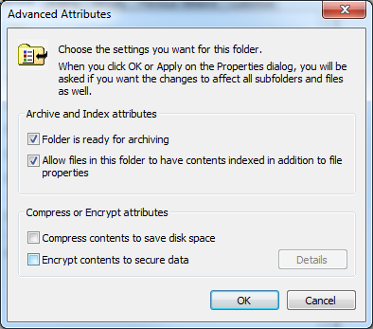
       4. Click OK
       5. A new box will open - select apply to subfolders button
13. Restart the BA Server
14. Login to PUC and open the Financial Services dashboard
    1. **Public > financial-services > dashboards > (CDE) Main**
15. The dashboard should look like the below image

